GDR HOWDI 2022 MEETING:
SAMPLE ABSTRACT AND PREPARATION INSTRUCTIONS

T. Emplate¹ and I. N. Structions²

¹University of Carbon Nanotubes, Dourdan, 91200, FRANCE
²Graphene Laboratory, Dourdan, 91200, FRANCE

The abstracts are limited to ONE page, including text and figures. The Abstract templates are available online in several formats. The template shall be completed and submitted in pdf format on the conference website: https://howdi2022.sciencesconf.org
PLEASE DO NOT CHANGE THE LAYOUT.

References
[1] S. Ample, Proc. MEMS 2008, pp. 100-103.
[2] A. B. Stract and S. Ample, Tech. Digest IEDM 2009, pp. 200-205.
[3] S. Mart and S. O. Lution, J. Journal, 23 (2006), pp. 300-315.

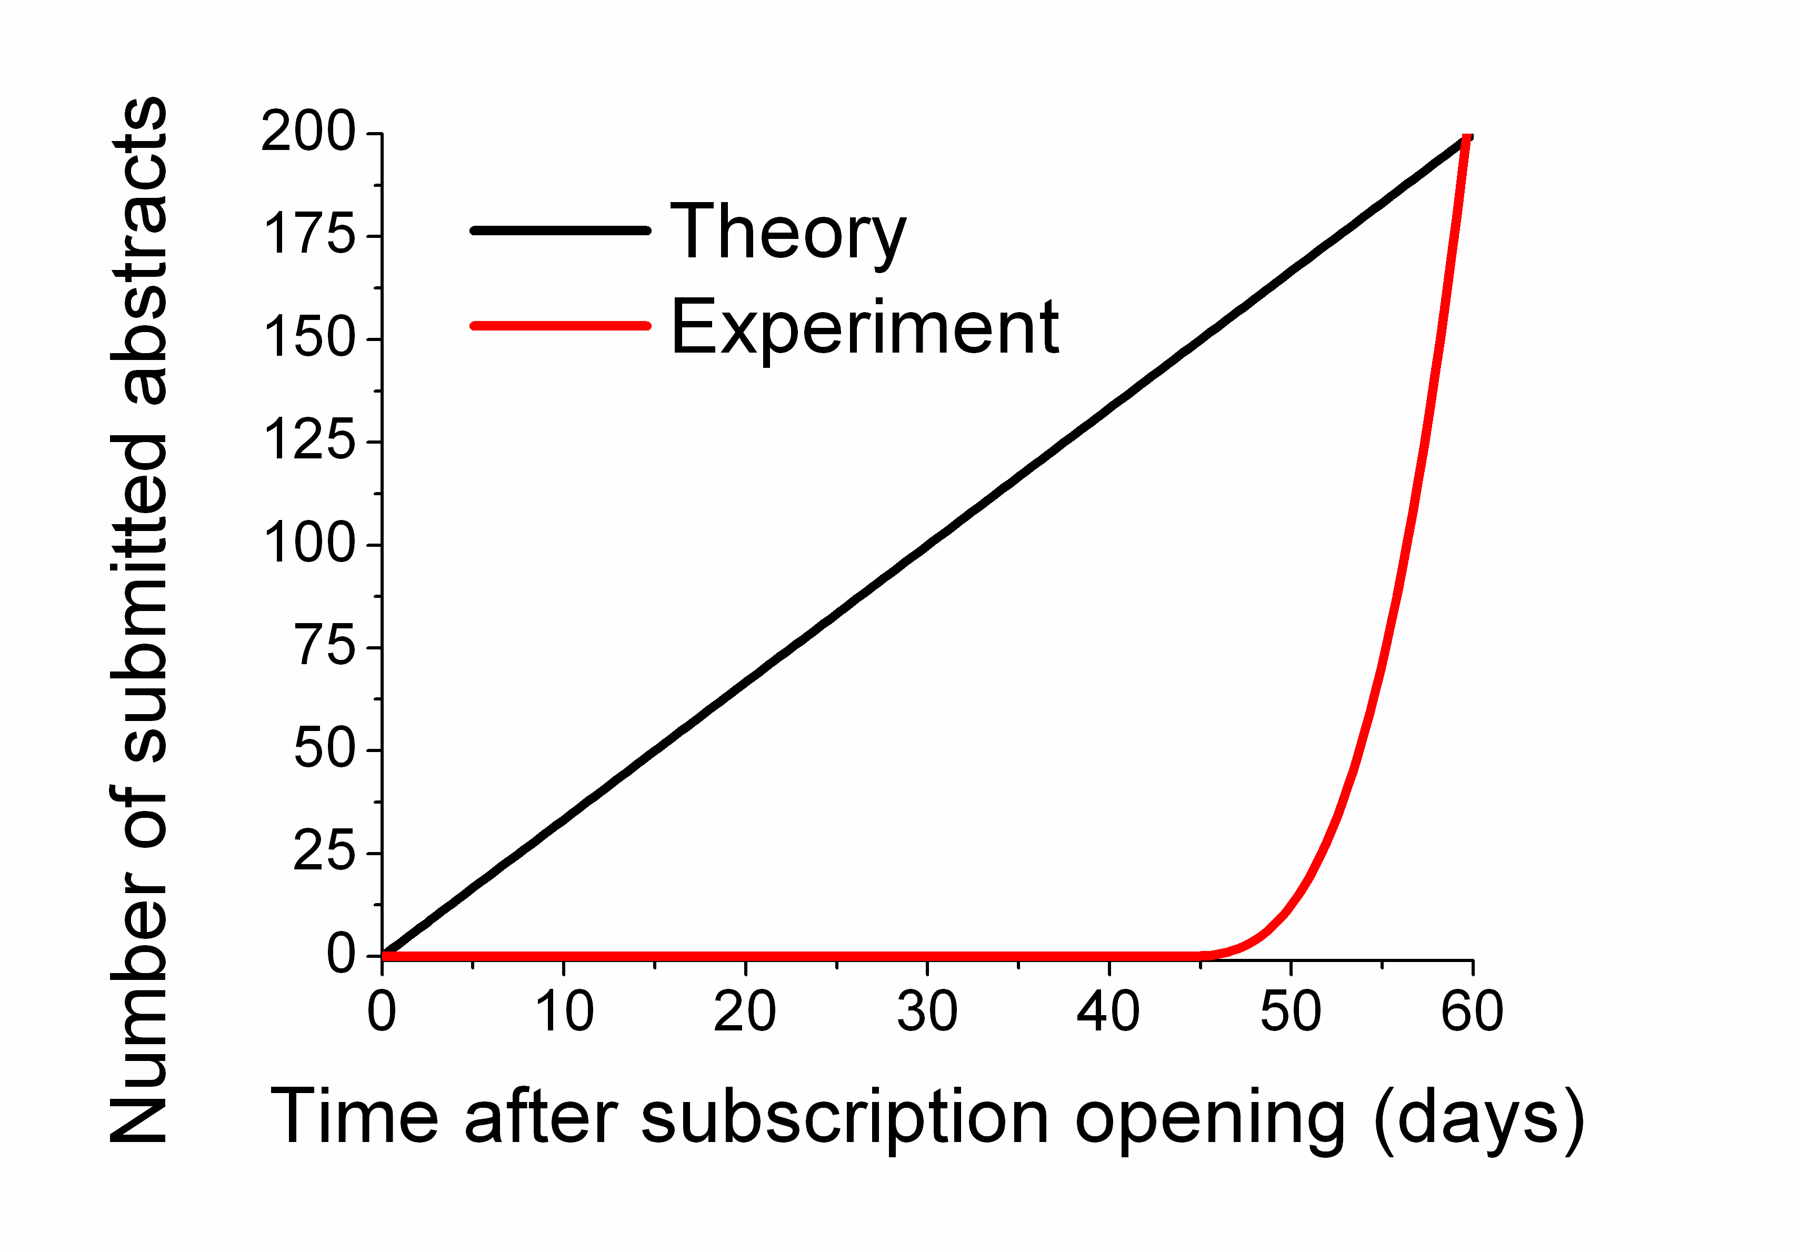

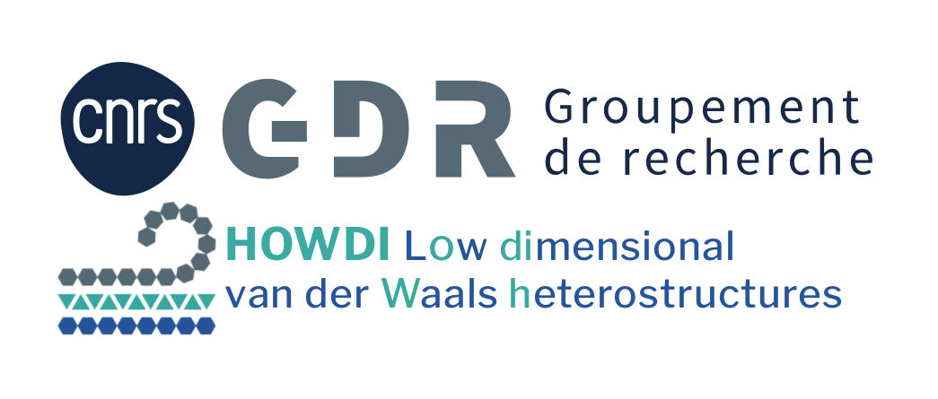

Figure 1: Conference logo.
Figure 2: Number of submitted abstracts versus time: theory in black and experimental values in red.

